**Lukáš Cafourek**

PART 3 - Academic Writing (10 points):

CHOOSE ONE of the following options (A or B) and write an ACADEMIC-STYLE TEXT on the next page.

Your writing must be a MINIMUM of 150 words and a MAXIMUM of 175 words.

Your writing should be RELEVANT, CLEARLY COMMUNICATED, WELL-ORGANISED, WELL-PRESENTED.

OPTION A: The diagrams below show the coastal village of Seaville in 1980 and 2010.

Summarize the information by selecting and reporting the main features and make comparisons where relevant. Write at least 150 words.

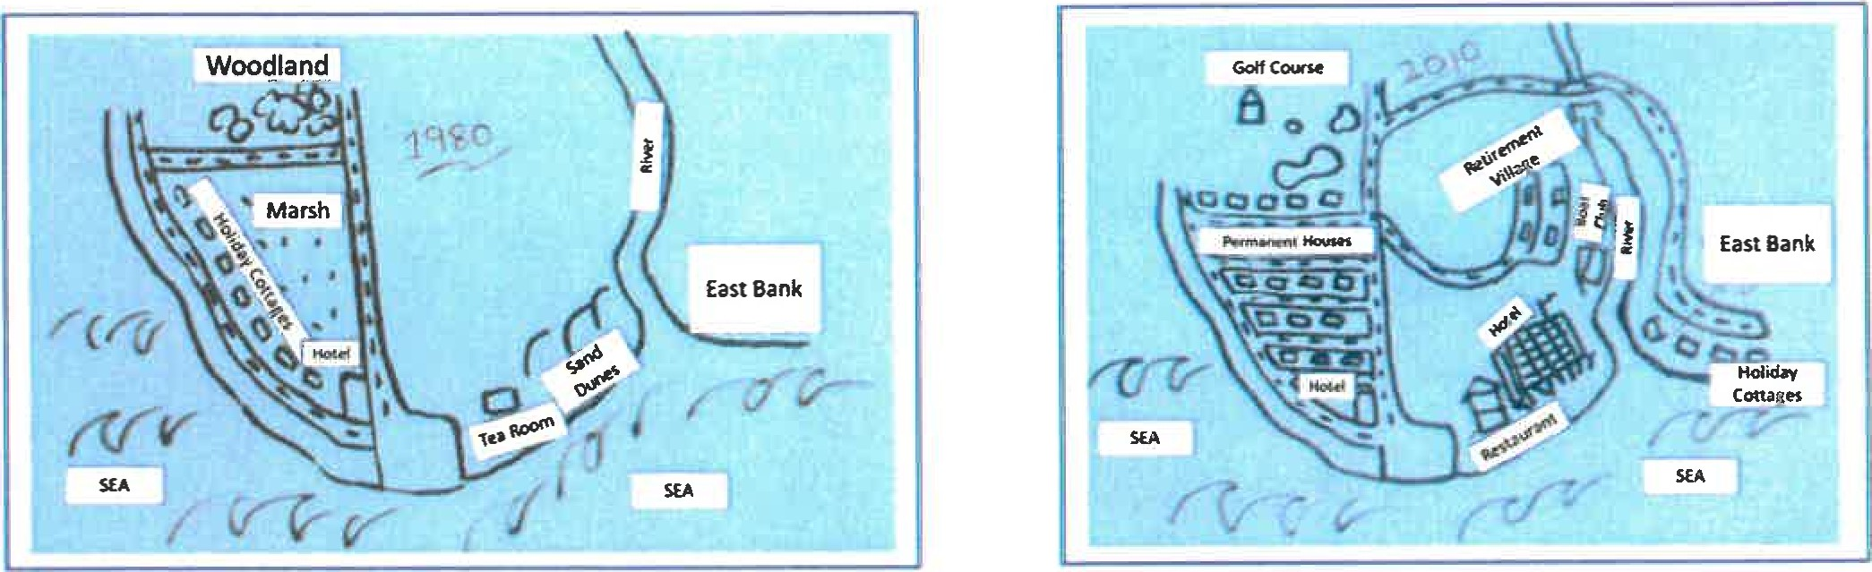

The two maps show the changes in the coastal town of Seaville between 1980 and 2010. The overall layout of the village had roughly remained the same, especially on the left side of the map. In both maps, the roads had not been modernized. Also, the small hotel on the west bank had not changed in 30 years.

In the 2010 map, a lot had changed. A road from the east bank to the town with a bridge across the river had been constructed. Furthermore, several blocks of houses had replaced the large marsh, and the holiday cottages had been moved to the sea on the east bank. A prominent hotel with a restaurant had been built on the site of the former tea room and sand dunes. In addition, a golf course had replaced the woodland. A retirement hotel with a driveway and a boat club had been added on the left bank of the river. Although many parts of the village had changed, the overall impression had remained the same.